Albert Street Uniting Church is a wonderful venue for the celebration of your marriage. Located on the corner of Albert and Ann Streets in the heart of the Brisbane CBD. The heritage listed church is red brick trimmed with Oamaru limestone and has been a favourite venue for weddings since 1889. The interior of rendered walls with wooden trim and panels and high ceilings frame the congregational space with a central aisle that leads to the sanctuary dominated by the pulpit and large decorated pipe organ. The many stained glass windows and lighting pendants provide subdued lighting. The upstairs balconies are available for large weddings and crowds and complement the peaceful and spiritual ambient space. It is a sacred space where a couple can exchange solemn vows in the presence of family and friends and receive God’s blessing.

**Helpful guidance**

You do not need to have specific plans and dates confirmed before you contact us: we are very happy to discuss your preliminary thoughts and ideas, answer any questions, and generally offer all the assistance we can to help with your preparations.

**Please use the “make an enquiry” link at the bottom of your screen to progress your interest in making your special day truly sublime, and we will be in return contact directly with you. Alternately, click on either of the links below to download our latest brochure and booking request form.**

**Weddings at Albert Street**

Congratulations on your engagement! We are delighted to welcome you to Albert Street Uniting Church as your choice of wedding venue.  
Our wedding services are structured by the Marriage Service Rites under the Uniting Church and can customise this service for your Wedding.   
As a picturesque location in the heart of Brisbane City beaming from red brick edge to limestone steeples, our Heritage Listed site is ideal for your Big Day event.  
Our prime location also ranks in [twelfth spot of best Wedding destinations](https://www.thebestbrisbane.com/top-wedding-venues-brisbane/) across Brisbane, and South East Queensland.  
The church chimes can be rung on the completion of your service.

[](https://www.thebestbrisbane.com/top-wedding-venues-brisbane/)

**Our Wedding Package**

**Preparation:**

In preparation for your special day, we invite you to meet our Minister by coming to our Brisbane Office.  
***It is a requirement by the Queensland Marriage Act for our Minister to sight your personal identification to confirm eligibility to marry.***   
And while you are here, it is a chance to discuss any questions you may have, or the possibility of using your own minister or pastor for your Big Day!

Deposit payment to secure the day of choice can be made on the day through EFTPOS with surcharge fee included, or through bank transfer.

After paying our friendly team will give some extra forms and information so we can create the best wedding experience for you!

**Our Wedding Package:  
​**

* Our Minister to oversee and facilitate the Wedding Ceremony, Legal paperwork, and the order of service to your liking.   
  PLEASE NOTE: If you would like to use your own minister, this can be worked in but will need to be discussed with our Minister first.
* Prepare Enrich Class: a marriage preparation course held in our function room, The Burnett Room, often held on a Saturday. This is a requirement of marriage. If you have completed the course prior let our friendly team know!  
  We serve you Morning Tea, Lunch and Afternoon Tea.   
  We host this in a group setting as we encourage wedding couples to form a cohort of their wedding year and like-minded friends and connection.
* Organist to play at your wedding
* A church office to ensure your special day is set up to your ideals
* Livestream options to remember your special day and provide a link for those unable to attend in person.
* A candle used both in the ceremony and a personalised wedding anniversary gift from us to you
* The Wedding Rehearsal prior to the Ceremony, and
* A choice of flowers displayed in the church
* First 6 pews decorated
* Electronic bells as you leave the church

​

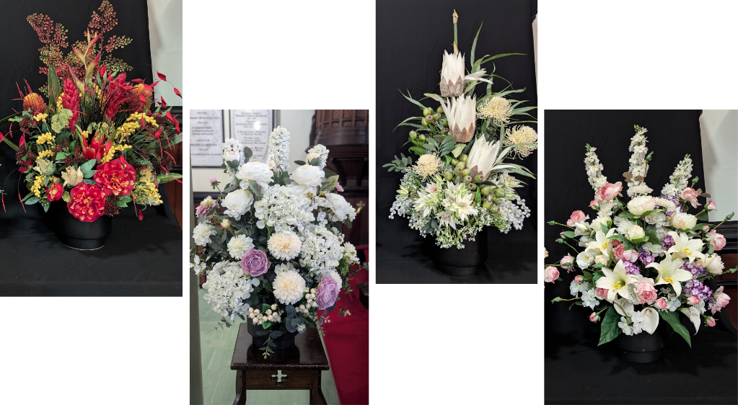Our Wedding Package comes to a total of $2,000 including the $100 deposit to secure your date.

